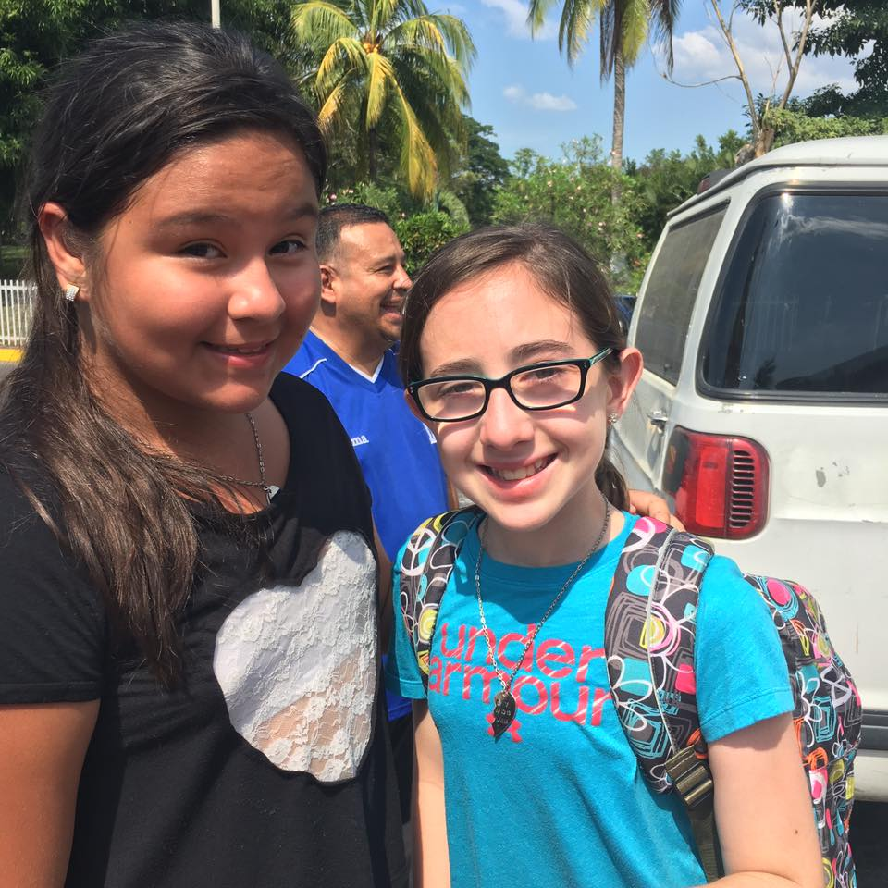

When I went to El Salvador this year it was the most impactful trip of my life! It was a very humbling trip, I saw thing I had never seen before. We went to places where it was nice but we also went to places that you could feel the poverty all around you. There where places where we went that all they had for a toilet was a cement hole in the ground. There was people cooking their meals on the dirty, asphalt street; there are no words to describe it.
Another thing I noticed was that even though they don’t have a lot they are happy because they are filled with the Holy Spirit and I personally think we as Americans could learn a lot from this - about being happy even though we don’t have everything and understanding GOD is everything we need.
We visited a lot of churches. On Sunday we went to two services and at one in particular I noticed that even though a lot of the congregation was children, the whole church was packed to the breaking point, whereas in the church I attend we barely fill all the seats one Sunday and the next there are only 30 people!! This made me realize that we have all these fancy buildings when these people are holding a bigger congregation in their own homes!
I knew all these things affected me while I was there, but by far the thing that affected me the most was the prayer! They pray very differently than we do, they all pray at once. When all of them pray, you can really feel the Lords presence. Their prayer is like an overwhelming tide of voices crashing to shore at the same time. I learned a lot in El Salvador, and from going there I feel closer to God.

