July 2016 Newsletter

“Our hope is that, as your faith continues to grow, our sphere of activity among you will greatly expand, so that we can preach the gospel in the regions beyond you.”
2 Corinthians 10:15b-16a
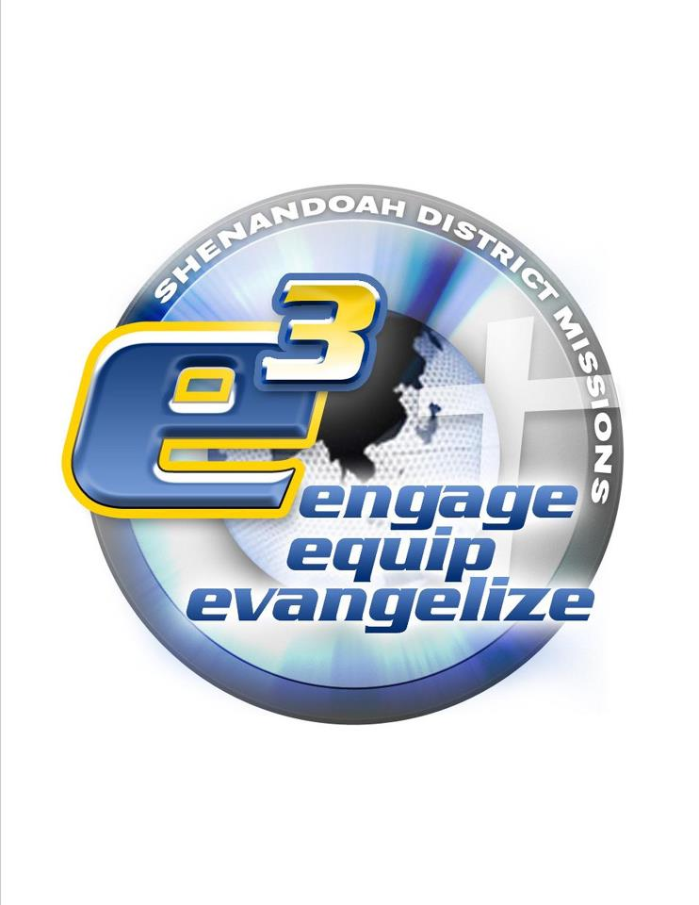

“The Christian church is God’s appointed means of spreading the gospel around the world. A church that is not a missionary church will quench the Spirit of God and miss His blessing. God’s agenda for history is ‘that all nations might believe and obey him’ (Rom. 6:26). All too often, however, the church has allowed itself to become self-centered, merely maintaining the status quo and failing to respond actively to this biblical directive.”

Taken from Second Edition Amazing Grace © Copyright 1990, 2002 by Kenneth W. Osbeck. Published by Kregel Publications, Grand Rapids, MI. Used by permission of the publisher. All rights reserved.

Our District is blessed to have many missionary churches that serve in a variety of ways. From local ministries to international missions, Wesleyans throughout Virginia and West Virginia respond to God’s will and give their time and resources to help others in need and further the Kingdom by showing God’s love for us to others. On behalf of your District Missions Board, we want to thank you for your continued service to our brothers and sisters here at home and throughout the world.

Contact Info—Shenandoah District Missions

Kelly Schuhmann (Director) jeffandkellys@gmail.com
Jonny Blatt jonny@reclaimchurch.org
David Daigneault ddaign8064@gmail.com
Charlene DeBord ckdebord@gmail.com
Kenny Dyer kdyer67@gmail.com
Ethelyn Kilmer rekedk65@gmail.com
Bob Phaup dc@shenandoahdistrict.ws
Sarah Torres maestra_k8@yahoo.com
Sara Willard swillard@parkwayroanoke.com

In this Issue—

page-2 My Testimony—El Salvador Missions Trip
by Vilene Horton

Vision—God’s Will
by Jonny Blatt

page-3 Venturing with the V–Team
by Rev Barry Van Steenburg, Jr

page-4 Outreach—How Can Your Church Make a Difference in Your Community
by Sara Willard

page-5 Church Partnerships with El Salvador
by Sarah Torres

page-6 3m project
by Dave and Donna Tolan

Check out our website!

We want to partner with you and support your missions programs.

We would also like to hear about projects your church is currently involved in. please contact any board member using our email addresses listed on this page.

www.shenandoahmissions.com

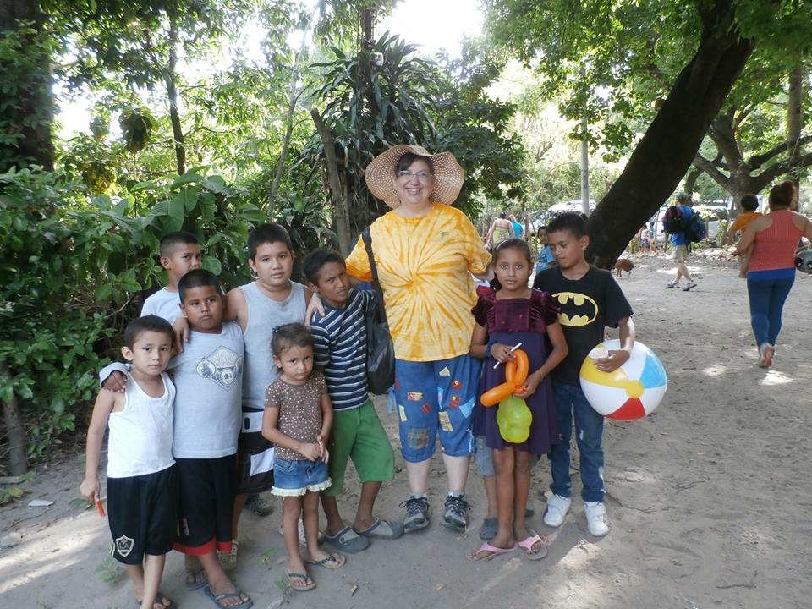

My Testimony—El Salvador Mission Trip
by Vilene Horton

It was a privilege and honor in July 2015 to travel to El Salvador on a missions trip with others in the Shenandoah District. I saw firsthand the courage and faith of the pastors and lay people in the Wesleyan Church of El Salvador. What a joy to worship with them, pray with them, and hear their testimonies of faith in God in the midst of suffering, poverty, and danger. Their joy, generosity, and compassion for lost souls are palpable. I love the creative ways that these believers reach their communities for Christ. For example, a church service has been established in the middle of a crowded market place where believers meet once a week to worship and hear the Word of God preached. Many vendors leave their booths of business to come to a narrow aisle where chairs have been set up for a church service. People have accepted Christ and are growing in their faith. Another way that the church meets needs in the communities is to provide medical clinic days where volunteers help screen patients, pass out nutrition supplements, aspirin, and dental care items, and a volunteer doctor examines the patients and provides treatment and prescriptions as available. The volunteer staff prays for the patients and it is a beautiful example of meeting both physical and spiritual needs of these impoverished people.

The gorgeous mountain, lake, and floral scenery of El Salvador is contrasted by the ugliness and destruction of vandalism as well as the hopelessness and fear that is all provided by the heavy gang presence in the country. Please pray for the safety of the believers in our churches in Central America. The churches are under attack because they are a threat to the recruit pool of the gangs. The gang leaders do not want young people to have hope, family, and purpose. They want to be the “family” for young people and use them as pawns in their promotion of drugs, greed, slavery, death and destruction.

I would encourage anyone with even a tiny bit of interest in taking a missions trip to pray earnestly and seek God’s will for you in this. It is a powerful experience and I know that I will never be the same.
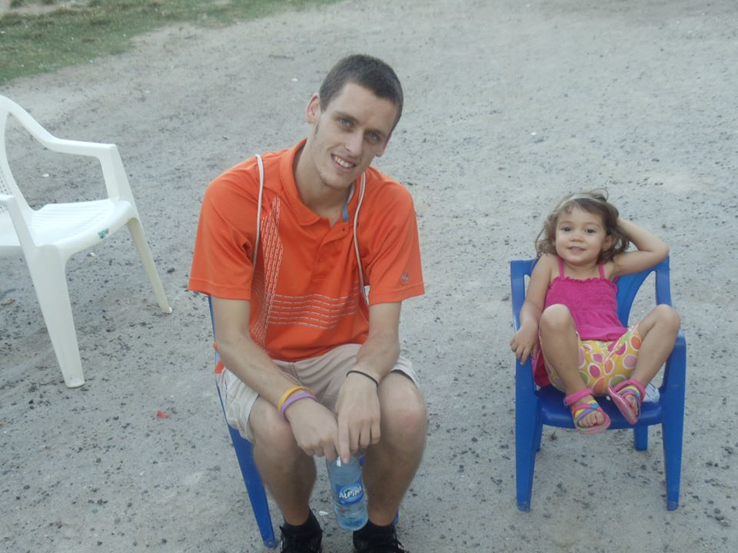

Vision—God’s Will
by Jonny Blatt

Do you feel like someone is pushing you to do something? Is there a constant feeling that something is missing in your life or you are forgetting an important task? Those of us which are involved with our church, often feel this notion or calling in our life. Good counseling and lots of prayer can most often help you determine that this feeling is God’s calling on your life. I recently had this exact experience in my own life. I knew there was more I should be doing in the mission field; however, I didn’t know what it looked like or where to begin. After many months of prayer, counseling, questioning, and reading, I believe that I have realized God’s call for my life. God was calling me to leave my home, church, family and friends to move to a completely different area in the world. As I prepare to move to El Salvador to assist in the ministry of the Wesleyan Church, God has continued to show me the way and put the plans in place. He has confirmed that calling in my life over and over! What is God calling you to take on in your life? Who are the people around you that can help you make it happen? How will you amplify the mission of God in your life? I challenge you to look at these questions and really think about your current life and God’s mission for you. Allow God to take you places that you never imagined and mold you into the person that you never felt capable of becoming.
Visit Jonny’s support page for more info—

http://www.globalpartnersonline.org/
missionaries/WM08-1122

Thanks for your prayers and support!

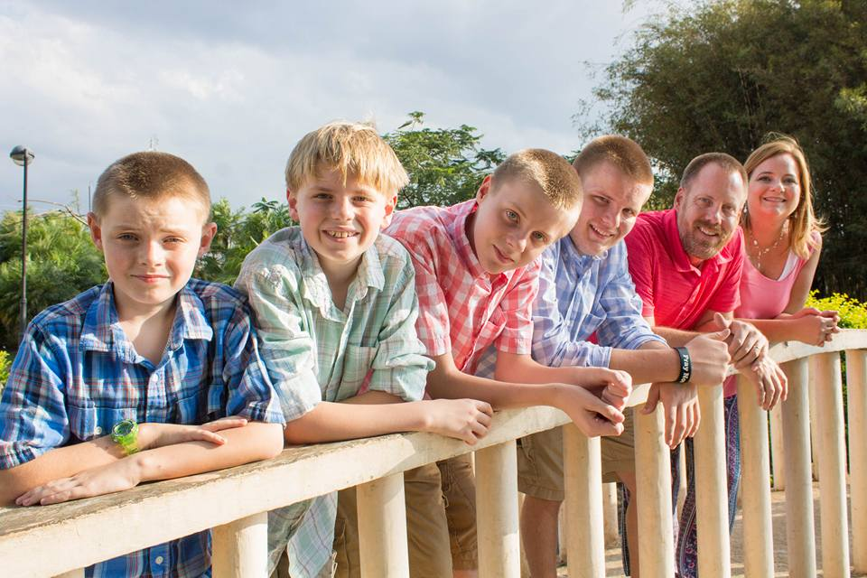

Venturing with the V–Team
by Rev. Barry Van Steenburg, Jr

Anybody like me, remember as a kid wishing the school year away; how the days always seemed to just drag by? Many moments throughout the school year I would find myself just dreaming about summer vacation and planning all kinds of activities that would just fill my summer days. Yet, without fail, summer after summer just seemed to slip through my fingers. It seemed as if I woke up one day and it was summer vacation and then I wake up the next and school was starting all over again. In a way, that's how these past 10 months have been for our family. Exactly 10 months ago this past Friday (24th) we found ourselves leaving the US for language school in Costa Rica. While we've learned an awful lot of Spanish as well as a whole bunch about Latin American culture, the time has just slipped us by. "Time flies when you're having fun." they say. Time flies when you're learning a new language, I say.

The reality we're faced with now is that in just over one month, we'll be transitioning to Managua, Nicaragua for the foreseeable future. We're in that weird and awkward space of trying to finish well at school, yet also trying to prepare well for life in yet another new country. In a period of less than 12 months we will face a second transition, to a second new country. We covet your prayers in this regard.
What will life and ministry look like once we arrive in Managua? That's a great question that we are still in the process of fully working out. Here are some things we do know. Thanks to some great teammates (who are have just transitioned back to a pastoral role in the States) we will have a house to move into and a vehicle to drive upon our immediate arrival. We will still have to work out selling that vehicle and adding some raised funds in order to purchase a vehicle more suited for our family size and ministry aims, but we’re thankful for some immediate access to a vehicle. We're super excited to be able to partner with an incredible family and fellow GP missionaries, the Schmitz's. We're eager to learn from them and partner with them in the work God is doing in Nicaragua.

As far as our specific roles and how GP intends to use us in Nicaragua, El Salvador, Honduras and Guatemala, those details are still working themselves out. At General Conference, approval was given for our area, Ibero-America, to move towards becoming its own Regionally Established Conference by 2019 (Praise the Lord). With that, there will be a greater partnership with the National Churches as to how we will serve in each of those countries. More to come!

Before we go, here are a couple of praise notes and prayer concerns that we'd ask you to raise with and for us:

Praise Notes:
* God's help and grace in learning Spanish
* A great community of partners who have carried us throughout these past 10 months
* God's continued supply towards our start-up fund

Prayer Concerns:
* The transition details
* As we prepare to say "goodbye" to some dear friends
* That we would "finish well"

With love and appreciation,
Barry

The Van Steenburgs are on Facebook. Visit Venturing with the V–Team for info and updates.

If you would like to partner with them and their ministry in Central America, please visit their page on the Global Partners website: http://www.globalpartnersonline.org/missionaries/WM04-0393

Outreach—How Can Your Church Make a Difference in Your Community?
by Sara Willard

“For even the Son of Man did not come to be served, but to serve, and to give his life as a ransom for many.” Mark 10:45

This verse is clear, isn’t it? Jesus came to serve. And He did. Jesus healed, preached, taught, listened, washed feet, prayed and much more. He did not spend His ministry days relaxing and watching other people serve…Jesus was hands-on.

As devoted followers of Jesus, we’re called to imitate Him. The Apostle Paul boldly proclaims, “Follow my example, as I follow the example of Christ.” (1Corinthians 11:1).

“How are YOU doing in this area?”
- If someone “follows” you…will they be led to Christ?
- How do you spend your time?
- Are you serving?
- Are you healing?
- Are you teaching?
- Are you washing other’s feet?”

“How is your church doing in this area?
- Is your church “known” for serving the community?
- Are you making an impact?
- Is there an atmosphere of serving within your church?

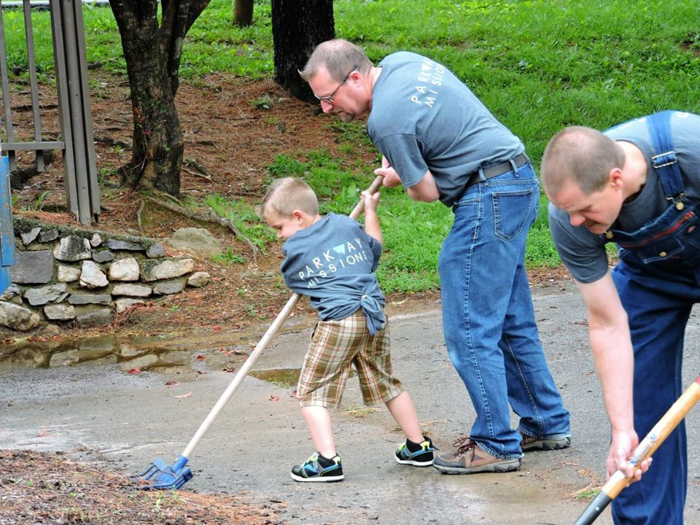

If Jesus came to serve, we ought to be serving, as well. As Missions Director of Parkway Church on the Mountain in Roanoke, VA, I have been challenged to lead this charge for our congregation. One of the ways that we serve our community is through a program called Serve Our City. We even initiated a hashtag #SOCROA (serve our city Roanoke) so we could easily track the year’s progress through social media photos.

Here are some of the ways our church served our city this year:
- Delivered cookies to fire & police stations (with an invitation to our July 4 church service)

- Distributed hot dogs on July 4 to the community while they watched the fireworks
- Helped put on VBS in the Parks
- Washed feet & handed out book bags at the Back to School Blast
- Distributed over 3000 magnet invitations to “Made New” Sunday
- Distributed dog biscuits with scripture verses at a dog show
- Helped at the Rescue Mission Family Chapel (45 people saved!)
- Collected items & delivered 50 “bags of hope” to cancer patients at the local Cancer Center
- Sent Christmas caroling teams to neighborhoods
- Visited veterans
- Prayed at various locations in the city for those who don’t yet know Christ
All of these activities require VERY little financial investment while providing “easy” opportunities for all ages to jump in and serve.
How does your church serve your community? Send us your creative ideas to inspire others to make a difference!
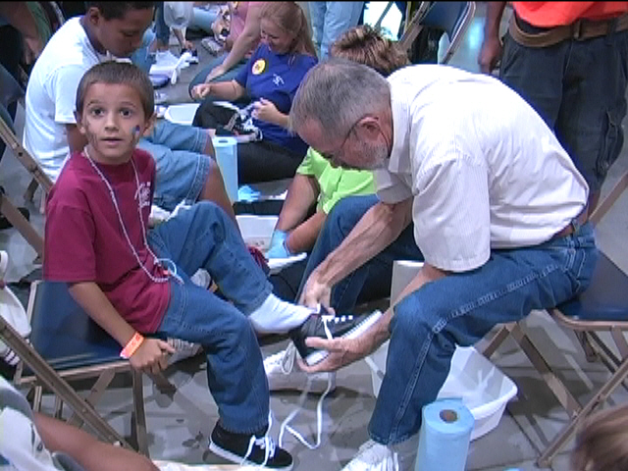

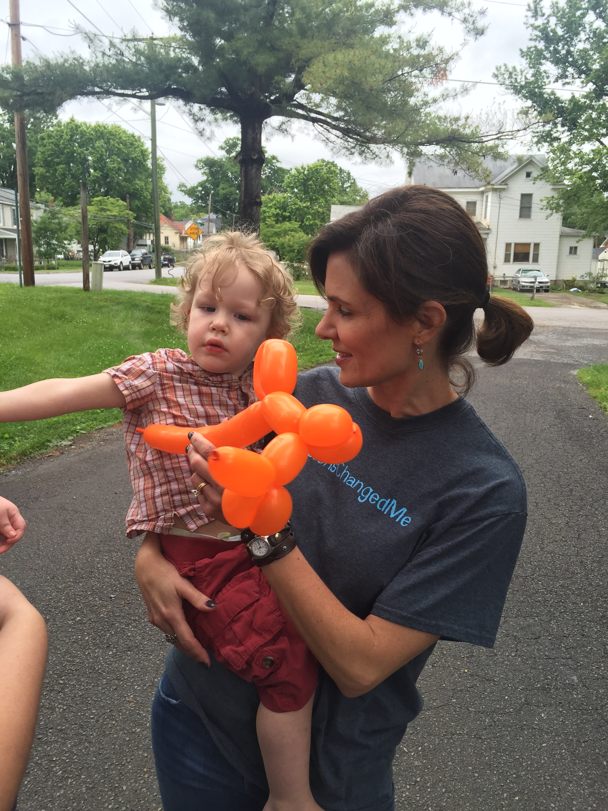

Church Partnerships with El Salvador
El Salvador, named for the Savior, is a beautiful country whose people are as warm as its climate. We believe God has given us a unique opportunity in the Shenandoah District to partner with His Church in this country to help these dear people come to know Jesus Christ, the Savior.
An important aspect of our partnership is the relationship we establish with individual churches in El Salvador. We need Shenandoah churches that are willing to come alongside and “adopt” Salvadoran Wesleyan churches, to help them as they grow and minister.
Adopting a church means:
*Sharing each other’s burdens and supporting each other mutually in prayer, even establishing individual prayer partners between the congregations
*Supporting special projects and giving financial support, either annually or on a monthly basis
*Sending mission teams to the sister church to work and minister
The Wesleyan Church in El Salvador is being used to carry the Gospel in amazing ways both within the country and beyond its borders, in spite of very limited resources. Would your church be willing to support them and share in the work?
If you and/or your church feel led to take an active role in our District’s partnership with El Salvador, please contact Sarah Torres at maestra_k8@yahoo.com for more information, and to begin the journey of working with the people of this beautiful country in God’s service.

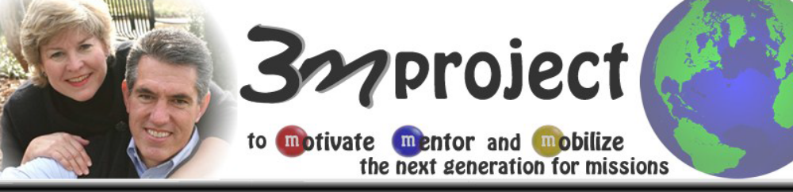

As Missions Mobilizers at Southern Wesleyan University, our purpose statement is: “To Motivate, Mentor and Mobilize the next generation for missions.”
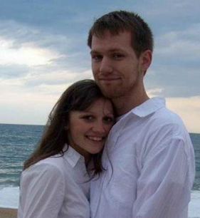
Recently we, Dave and Donna Tolan, said “goodbye’ to another couple as they boarded their plane to begin their missions assignment in Cambodia. Ryan and Melissa will be teaching English at a major university and building redemptive relationships with Cambodian friends; while also seeking to bring freedom and healing to those enslaved in the horrific sex trafficking trade.
Motivate... As a freshman, Ryan attended Student Missions Focus, a student organization at SWU that we help lead. During one of our meetings, Noelle, a SWU graduate who had served with World Hope in Cambodia, shared about her work with young girls rescued from the sex trafficking trade.
Motivate... Earlier that summer I (Dave) had become deeply burdened by the need for ministry to young boys enslaved in the sex trafficking trade; boys who are forced to look and act like girls for the warped sexual pleasures of sick men. I could see that Ryan was impacted by Noelle’s story. After the meeting I sat down with Ryan and asked, “Ryan, what about the boys? Who is going to do something for the boys?”
Mobilize... That question haunted Ryan and two years later he and Timmy, another SWU student, spent their summer in Cambodia working with young boys rescued from the awful sex trafficking trade. When Ryan and Timmy returned, they mobilized the SWU community to help build a ministry center where these boys could receive healing and education and experience the real and redemptive love of a kind and gentle man named Jesus.
While at SWU, Melissa was one of our top cross-country runners. Melissa also has a huge heart for abused and unloved children. She has worked extensively with orphaned and marginalized children in the US and over-seas. Children see Melissa’s smile and look into her kind eyes and are convinced she genuinely loves them.
Ryan and Melissa are one of six SWU couples who recently began long-term missionary service.
Please pray for Ryan and Melissa. They are serving in Cambodia and recently had a baby boy.
By the way...this is not a story about us. It is a story about your faithful prayers, the Holy Spirit, and Ryan and Melissa’s obedience.

